# **Modular Enclosure Block Validation**

**Block Champion: Astrid Delestine**

**Date: Jan-25-2024**

## **1. Description**

This block consists of several different elements, the primary being a 3d printed or injection molded box that contains many different electrical systems. This block exists primarily to protect these electrical components. This block is also modular, meaning that the interfaces it connects to will have a standardized connection metric, allowing for the swapping of physical components if one were to break. It also contains the temperature sensor as this sensor was deemed most suitable to be contained within this block. The temperature sensor that we have chosen is the DS18B20 Temperature Sensor. As it will be contained within this block, this block will need to make a data connection to the e-ink display, where the information processing happens. This Temperature sensor will be connected to the modular enclosure by physical clips mainly for strain relief. The container will be made of Polyethylene terephthalate glycol or PETG. This material has been chosen due to its low reactivity with other materials and its food-safe nature. This is important as this block will be exposed to harsh elements such as rushing water, and possibly high temperature. As this block covers most individual electrical components of the system, it must be watertight, this will be achieved by having a TPU gasket that is hidden when the enclosure is sealed. The dimensions of this block depend heavily on the user accessibility blocks, and therefore it may change over time. The minimum width of this block will have to be three inches to include any dials, buttons, or switches, in addition to the e-ink display. It will be the major retaining force connecting the project to the fish tank itself. This will be achieved using a screw and nut system where the user will slide the block over the edge of the fish tank, and a large plastic screw will hold the box perpendicular to the fish tank allowing for structural stability. Due to this structural element, the height of the entire unit will be at least five inches in total and it would be best to keep it under ten inches, otherwise the system may be considered bulky. The final dimension to consider for this block would be its depth. Due to this block not being a simple cuboid, there may be multiple depths, in addition to connectors that may slightly increase or decrease depth. It can again be generally considered a good idea to have this dimension not exceed the depth of the fish tank (ie twelve inches). A minimum possible dimension can be set at two inches, however a more expected depth may be up to four or five inches. The modular connections that will integrate various PCB designs, may include sliding rails that attach to the designed hole structures on the PCB, allowing for quick swapping of components, as stated earlier. It may be necessary to coat this enclosure in a water-phobic layer, to allow water to bead off of it, however, this will require material testing. There will need to be holes in the front of the enclosure to account for the user input buttons, dial, and e-ink screen. While this may impact water resistivity these holes will be on the front of the device, where water will vary rarely splash on it.

## **2. Design**

There are six different interfaces in the modular enclosure. They will be referenced in a clockwise direction starting at the top left. The first interface, outside modular enclosure mechanical, denotes a mechanical connection between the outside world and this enclosure. The second interface, outside modular enclosure analog signal, represents the connection between the temperature sensor on the outside of the enclosure streaming data into the modular enclosure. The third interface, sensor contacts modular enclosure mechanical, represents a mechanical connection between the sensor contact block and the module enclosure. The fourth interface, sensor contacts modular enclosure DC power, supplies the power needed for the temperature sensor. The fifth interface, the modular enclosure sensor contacts analog signal, passes the temperature sensor signal data along to the sensor contact board. And finally, the sixth interface, modular enclosure color sensor enclosure mechanical, connects the modular enclosure to the color sensor enclosure and testing unit.

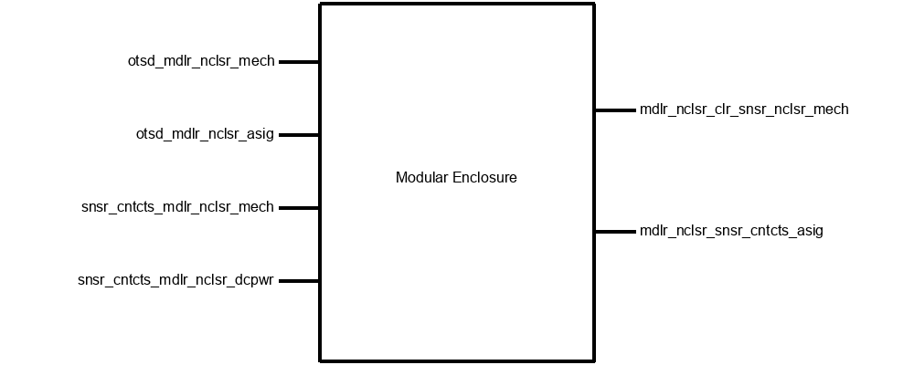

**Block Diagram**

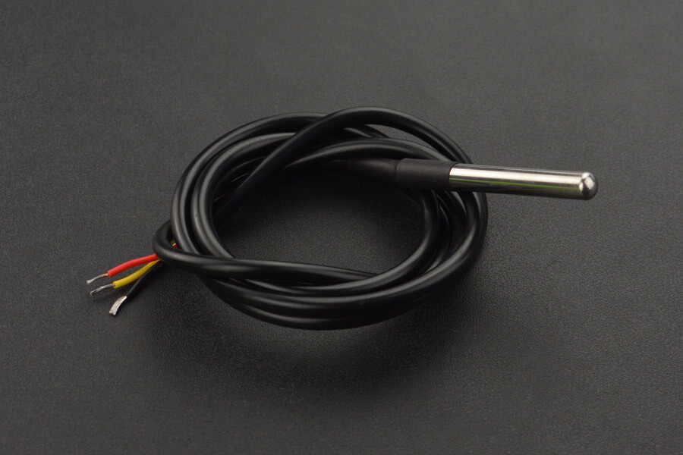

**Temperature Sensor**



**3d Design Schematic (TBD)**



**Modular Connector**



**Temperature Sensor Strain Relief**

## **3. General Validation**

There were many different decisions that were made when designing this block. Chief among them is the use of PETG as the enclosure material. Initially, Polylactic acid or PLA was suggested as it is the easiest to work with, and is the most available, however, we quickly learned of its downsides. Anything made with PLA is technically biodegradable, thus meaning that it would wear down quickly over time, and leech small pieces into the fish tank. This was unacceptable for fish tank enthusiasts, so more research needed to be done. PETG was then recommended as it is still fairly easy to work with, and it is a full polymer meaning it does not biodegrade, and it is foodsafe. PETG is also fairly comparable in price, thus it was chosen.

Another major consideration that was made, was in regards to how to attach different elements to this enclosure. Initially, the main idea was to have the elements connect directly to a main enclosure, however, the choice to containerize all the blocks of this project was suggested resulting in an idea for modularization. In this way, we can make small changes to the individual blocks, and they can connect to the main enclosure using global interface adapters. Not only does this decrease the material cost in the prototyping phase, but it also will allow for user-serviceable upgrades, and the possible addition of new systems. The specific connector design can be described as a set of linear rails, that circuit boards or other modules ride along.

The decision to incorporate the temperature sensor into this specific block was driven by several factors. Primarily, it is intricately linked with this particular block, making it the most logical choice. Integrating the temperature sensor into a different block, such as the sensor contact block, would be impractical, given that the latter primarily deals with inputs and outputs. Additionally, the inclusion of the temperature sensor in this block contributes to the overall strain relief for the sensor, further justifying its placement. Additionally, this sensor is extremely inexpensive, available, and easy to implement as it sends an analog data signal.

## **4. Interface Validation**

| **Interface Property** | **Why is this interface this value?** | **Why do you know that your design details for this block**  **above meet or exceed each property?** |
| --- | --- | --- |
| **otsd_mdlr_nclsr_mech: Input** | | |
| Fasteners: Plastic Screw | A large plastic screw allows for various methods of clamping force on the walls of the fish tank without scratching it as a metal fastener might. | This is known to meet or exceed as this is a material constraint. It will be made of the same material as the enclosure. |
| Pulling Force: >0.5N | A pulling force is specified as such due to the testing requirement of layer separation when 3d printing. | I am confident this will exceed 0.5N as I have seen PETG with a layer adhesion of around 25kg of pulling force applied. This translates to approximately 245N of force |
| Twisting Force: >1N | The twisting force is required as there may be small amounts of torque when the user is using the system. | Again I am confident this will surpass the requirement of 1N due to testing done by CNC Kitchen  [2] |
| **otsd_mdlr_nclsr_asig: Input** | | |
| Other: Operating Current: <3uA | The current expected from the temperature sensor | This will be met as it is the specification provided by the datasheet for the sensor |
| Other: Interface: Digit (unibus) | The description of the data interface from the temperature reading | This will be met as it is the data interface provided in the datasheet by the manufacturer |
| Vrange: 3.0v~5.4v | The voltage coming from the temperature sensor | This voltage will be met as it is the same as the voltage heading to it |
| **mdlr_nclsr_clr_snsr_nclsr_mech: Output** | | |
| Fasteners: friction | The use of friction-based fasteners ensures a secure and stable connection between enclosures, facilitating easy assembly and disassembly for maintenance purposes. | The design specifies the use of friction-based fasteners explicitly to ensure a secure and stable connection, enabling easy maintenance and disassembly. |
| Other: Material: PETG | PETG material provides water-resistant properties, suitable for the proximity to water as required for the enclosure. | The material chosen (PETG) offers water-resistant properties, meeting the requirement for use near water. |
| Shear Force: >1N | The PETG material chosen for the enclosure has a shear force strength exceeding 1N, ensuring durability and structural integrity under tensile forces. | Material testing confirms that the PETG used in the enclosure has a shear force strength exceeding the specified value, guaranteeing its durability. |
| **mdlr_nclsr_snsr_cntcts_asig: Output** | | |
| Other: Interface: Digit (unibus) | The current expected from the temperature sensor | This will be met as it is the data interface provided in the datasheet by the manufacturer |
| Other: Operating Current: <3uA | The description of the data interface from the temperature reading | This will be met as it is the specification provided by the datasheet for the sensor |
| Vrange: 3.0v~5.4v | The voltage coming from the temperature sensor | This voltage will be met as it is the same as the voltage heading to it |
| **snsr_cntcts_mdlr_nclsr_mech: Input** | | |
| Fasteners: Plastic Clips | Plastic clips will connect the sensor contacts board to the modular enclosure | This is guaranteed by the material design specification |
| Other: Additional Adhesion: Hot Glue | If necessary hot glue can be used to electrically isolate and adhere the sensor contact board to the modular enclosure | This is understood to be necessary due to the proximity to water, and it can be easily removed if necessary as well. |
| Pulling Force: >1N | The pulling force is required as there would be major failures in the system if the sensor contacts disconnected. | This can be seen to be tested and working via the CNC kitchen video, where PETG has a force tolerance of over 200N |
| **snsr_cntcts_mdlr_nclsr_dcpwr: Input** | | |
| Ipeak: 3uA | This is the maximum expected amperage draw from the temperature sensor | This is expected to meet expectations due to its documented nature in its datasheet |
| Vmax: 5.4v | This is the rated max voltage for the temperature sensor | This is expected to meet expectations as this follows the datasheet information |
| Vmin: 3.0v | This is the minimum operational voltage for the temperature sensor | This is expected to meet the expectations as it follows the datasheet information |

## 

## **5. Verification Plan**

For interface **otsd_mdlr_nclsr_mech:**

* The plastic fastener will be tightened with fingertips, this allows for a maximum torque of 5-15 NM. This is overkill for our system therefore it can be considered as meeting the requirement. Due to the nature of pressure exerted using a tension screw like this both pulling force and twisting force requirements are satisfied by this test.

For interfaces **otsd_mdlr_nclsr_asig,   
 mdlr_nclsr_snsr_cntcts_asig,**

**snsr_cntcts_mdlr_nclsr_dcpwr:**

The data output can be measured using a direct hookup to an oscilloscope

* Supply voltages at 5.4v and 3.0v
* Current limit sensor to 3uA
* Confirm correct data using laser thermometer

For interface **mdlr_nclsr_clr_snsr_nclsr_mech:**

* Fastener type can be inferred visually
* Material type can be determined by burn test. If it burns with a yellow flame, it is PETG
* The shear force can be tested by pushing along a side with layer lines. To measure a force of 1N you would need 1kg/meter or an equivalent ratio.

For interface **snsr_cntcts_mdlr_nclsr_mech:**

* Fastener type can be inferred visually
* If hot glue is present it will be very visible. Look for visible signs of hot glue
* To test for 1N of pulling force, attempt to push the board through the clips. If it does not break the box, the test succeeds.

## **6. References and File Links**

[1] [Ultimaker_PETG_TDS.pdf (dynamism.com)](https://www.dynamism.com/media/catalog/product/pdf/Ultimaker_PETG_TDS.pdf)

[2] [Comparing PLA, PETG & ASA - feat. PRUSAMENT — CNC Kitchen](https://www.cnckitchen.com/blog/comparing-pla-petg-amp-asa-feat-prusament)

## **7. Revision Table**

| 12/6/2023 | Initial Draft |
| --- | --- |
| 12/7/2023 | Completed Draft |
| 1/25/2024 | Updated and revised Draft |

# **Power Management Block Validation**

**Block Champion: Astrid Delestine**

**Date: Jan-28-2024**

## **1. Description**

This module serves the crucial function of supplying power to interconnected devices. It is meticulously designed seamlessly to connect to an external USB C cable strictly adhering to the USB 2.0 power delivery standard. According to this standardized protocol, a request for 5 volts at 2 amps necessitates the pulling down of the CC1 and CC2 pins on the USB C connector, achieved through a 5.1k resistor. This action informs the controller on the wall power brick ensuring the correct voltage and amperage is delivered. The USB C connector model employed is 12401832E402A. This particular model was chosen due to its low cost and high availability from Digikey. While this module is responsible for powering the entire board, it does not perform any power conversion to 3.3 volts, as the E-Ink module incorporates a built-in function for this purpose. At the time of writing, there are no external sensors to the e-ink panel that require 3.3v. As some of the documentation surrounding the USB C connector needs to be clarified, there will be four jumpers that the team will need to test and solder. This way we can extensively test and understand the exact power output paths. These jumpers would be removed on a production run of this chipset. There will also be an indicating light-emitting diode that will allow the user to certify that the block has power, and is supplying power to the other blocks. The LED itself will be a small, discreet green diode strategically positioned facing away from the fish tank, prioritizing an unobtrusive aesthetic and minimizing the chance that the fish will be affected. Additionally, there will be a surface board-mounted sliding power switch serving as a central control point for all power runs. This switch will be placed next to the light-emitting diode and will be accessible to the user. This way the user can easily tell quickly that the system is receiving power and if they want to disable the power output for any reason, can. Many pins on the USB C connector are not mapped as they correspond to different data protocols, and as this port will not be used for data, we can avoid using them entirely. For testing and emergency purposes, pads for the data ports of the USB C connector will be broken out.

## **2. Design**

**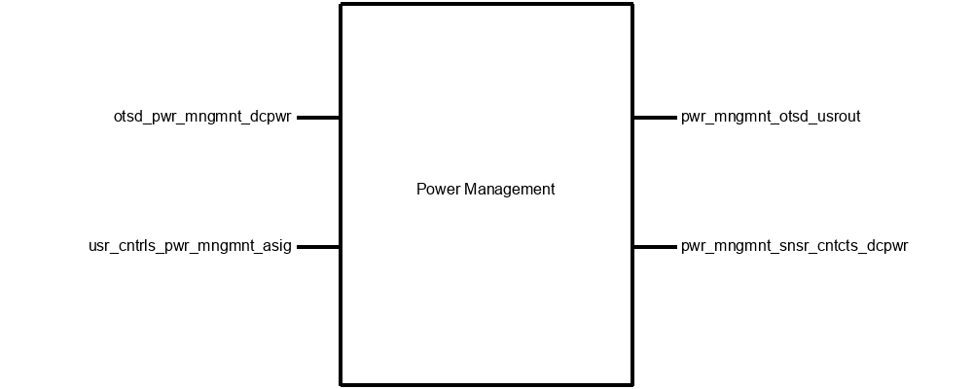  
Block Diagram**

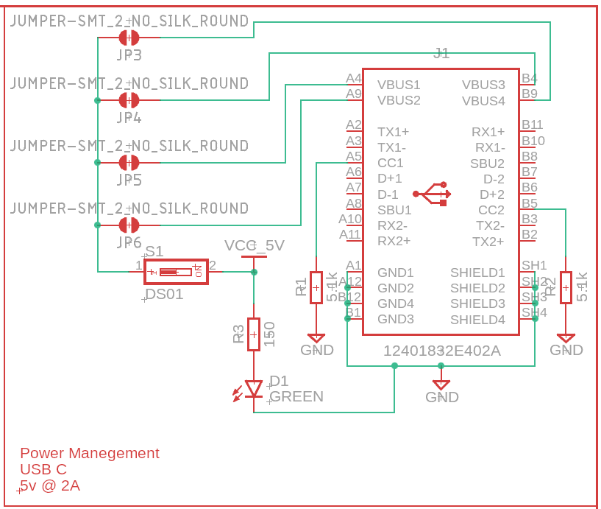

**PCB Drawing**

## **3. General Validation**

The power management block comprises multiple components, each tasked with specific functions to ensure optimal system performance. Its primary objective is to provide the entire system with the necessary voltage and current, while concurrently regulating power states and conveying crucial information about the power supply status to the user.

In initiating the power supply task, an external power supply brick plays a pivotal role. This device serves as the primary unit responsible for stepping down and converting the 120-volt alternating current to a five-volt direct current. Adhering to the current USB C standard, these converters default to a power output of five volts at half an amp. However, we implement a modification using two 5.1 thousand ohm resistors, strategically pulling down the CC1 and CC2 pins of the USB C port to ground. This alteration results in an increased amperage of two amps, facilitating subsequent distribution to other blocks within the project.

Moving to the aspect of power limitation across the system, a dedicated power switch is strategically positioned between the input power derived from the USB C port and the five-volt output to the system. This placement enables efficient shutdown of power when required. Complementing this functionality is a conspicuous green LED designed to inform the user about the operational status of the power supply, providing a visual confirmation of the power supply to the system.

While monitoring power supply status is imperative, it is only one facet of our comprehensive approach to mitigate system failures. Our strategy encompasses a multi-faceted approach, incorporating various measures to enhance the overall reliability and robustness of the system.

## **4. Interface Validation**

| **Interface Property** | **Why is this interface this value?** | **Why do you know that your design details for this block**  **above meet or exceed each property?** |
| --- | --- | --- |
| **otsd_pwr_mngmnt_dcpwr: Input** | | |
| Inominal: 500mA (TBD) | This value is determined by the current draw of the system. It can be assumed that the current draw of the system will be below 500mA however the TBD moniker has been attached as we will fine-tune this measurement as time goes on. | This is satisfied in this block by designing traces that can carry 5v at 2A. Therefore they will be overengeered and easily be able to carry 500mA |
| Ipeak: 1.8A | The current this connector is rated for is 2A, therefore, we have chosen a slightly decreased value. | This is satisfied in this block by designing traces that can carry 5v at 2A. Therefore the peak current can reach 1.8A before losses or other unexpected situations occur. |
| Vmax: 5.1v DC (TBD) | The maximum voltage this USB C specification is rated for using our current setup. | This is satisfied by the two resistors that pull CC1 and CC2 down to ground. Allowing 5v to be triggered from the power supply |
| Vmin: 4.9v DC (TBD) | The minimum expected voltage this USB C specification is rated for using our current setup. | This is satisfied by the two resistors that pull CC1 and CC2 down to ground. Allowing 5v to be triggered from the power supply |
| **pwr_mngmnt_otsd_usrout: Output** | | |
| Other: Color: Green | This color has been chosen to allow for 9/10 user to understand that a green light means the system is working | This can be confirmed in this block by choosing the correct LED light color, when ordering parts |
| Type: Light (LED) | This type has been chosen as opposed to an incandescent or HV light source due to the low voltage of the system. | This can be confirmed by seeing if the LED lights when power is applied |
| Usability: Understandable by 9/10 | It is expected that 9/10 users will be able to tell if the system is on via this power management LED | This will be confirmed by asking classmates and co-workers if they can think the system is on or not |
| **pwr_mngmnt_snsr_cntcts_dcpwr: Output** | | |
| Inominal: 500mA (TBD) | This value is determined by the current draw of the system. It can be assumed that the current draw of the system will be below 500mA however the TBD moniker has been attached as we will fine-tune this measurement as time goes on. | This can be shown to be true by measuring the output of the DC power system with a simulated load. |
| Ipeak: 2A | The maximum rated current that can be momentarily sent to the various systems in the project | This can be shown to be true by increasing that simulated load to 2A for 10 seconds |
| Vmax: 5.1v DC (TBD) | The maximum voltage the devices inside the fish tank monitor can accept. TBD due to the fact that this may change with further testing. | The max voltage can be shown true if the input voltage is changed to match |
| Vmin: 4.9v DC (TBD) | The minimum rated voltage at the devices inside the fish tank monitor can work reliably. TBD due to the fact this may change with further testing | The max voltage can be shown true if the input voltage is changed to match. |
| **usr_cntrls_pwr_mngmnt_asig: Input** | | |
| Other: Max Current: 2A | The max current expected to flow through the power management user control port, this is also known as the power switch. | This is known to be true via simulations that can be run in fusion 360 |
| Vmax: 5.1v DC (TBD) | The maximum voltage this USB C specification is rated for using our current setup. | This is known to be true via simulations that can be run in the fusion 360 |
| Vrange: 0-5v DC | The rated voltage that this particular switch line will be expected to be at. | This is known to be true via simulations that can be run in fusion 360 |

## **5. Verification Plan**

1. Connect the USB C port to an existing, known good, power supply unit.   
   (ie <http://tinyurl.com/ankGan> )
2. Probe the test pads, they will be labeled as per the following:
   1. 5v
   2. GND
3. A current test can be done by bridging the respective contacts allowing for current to flow through the testing medium of choice.
4. Turn the power switch on, does the LED light?
5. Is there 5v at the testing lead?
6. What current is flowing?

## **6. References and File Links**

[1] [io_usb_type_c.pdf (amphenol-cs.com)](https://cdn.amphenol-cs.com/media/wysiwyg/files/documentation/datasheet/inputoutput/io_usb_type_c.pdf)

[2] [Block Diagram Entry (oregonstate.edu)](https://eecs.engineering.oregonstate.edu/capstone/ece/student/blockdiagram.php)

## **7. Revision Table**

| 12/6/2023 | Initial Draft |
| --- | --- |
| 12/7/2023 | Completed Draft |
| 1/25/2024 | Completed Final Draft |